

ApniNewz

#### Developed By:

#### Aryan Panchal 205170686026

#### Umang Patel 205190686051

#### Kalp Shah 205170686017

**Group No: MCA_10_G30**

#### Under the Guidance of: Khushali Vala

**Submitted To:**

L.J. Institute of Computer Application

**L.J. INSTITUTE OF COMPUTER APPLICATION**

Near Nagdev Kalyan Mandir, Near Sarkhej Cross Roads,

Sarkhej-Gandhinagar Highway Ahmedabad - 382210 Ph. No.: 079 29296364



##### CERTIFICATE

**Enrollment No**: **205170686019**

This is to certify that Mr. / Ms. **Aryan Panchal** studying in Integrated Master of

Computer Applications, Semester IX, Roll No **ICA-19** has satisfactorily

completed his/her Project Titled **ApniNewz** under the supervision of

**Prof. Khushali Vala**

**Internal Guide Name: Signature**

Prof.

**Date of Submission:**

**Director Prof. Aalok Manke**

**L.J. INSTITUTE OF COMPUTER APPLICATION**

Near Nagdev Kalyan Mandir, Near Sarkhej Cross Roads,

Sarkhej-Gandhinagar Highway Ahmedabad - 382210 Ph. No.: 079 29296364



##### CERTIFICATE

**Enrollment No**: **205180686038**

This is to certify that Mr. / Ms. **Umang Patel** studying in Integrated

Master of Computer Applications, Semester IX, Roll No **IMS-38** has

satisfactorily completed his/her Project Titled **ApniNewz** under the supervision

of **Prof. Khushali Vala**

**Internal Guide Name: Signature**

Prof.

**Date of Submission:**

**Director Prof. Aalok Manke**

**L.J. INSTITUTE OF COMPUTER APPLICATION**

Near Nagdev Kalyan Mandir, Near Sarkhej Cross Roads,

Sarkhej-Gandhinagar Highway Ahmedabad - 382210 Ph. No.: 079 29296364



##### CERTIFICATE

**Enrollment No**: **2051806860**

This is to certify that Mr. / Ms. **Kalp Shah** studying in Integrated

Master of Computer Applications, Semester IX, Roll No **IMS-** has

satisfactorily completed his/her Project Titled **ApniNewz** under the supervision

of **Prof. Khushali Vala**

**Internal Guide Name: Signature**

Prof.

**Date of Submission:**

**Director Prof. Aalok Manke**

Table of Contents

1. INTRODUCTION 7

1.1. EXISTING SYSTEM 8

1.2. NEED FOR THE NEW SYSTEM 8

1.3. OBJECTIVE OF THE NEW SYSTEM 8

1.4. PROBLEM DEFINITION 9

1.5. CORE COMPONENTS 9

1.6. PROJECT PROFILE 10

1.7. ASSUMPTIONS AND CONSTRAINTS 10

1.8. ADVANTAGES AND LIMITATIONS OF THE PROPOSED SYSTEM 11

2. REQUIREMENT DETERMINATION & ANALYSIS 12

2.1. REQUIREMENT DETERMINATION 12

2.2. TARGETED USERS 13

3. SYSTEM DESIGN 14

3.1. USE CASE DIAGRAM 14

3.2. CLASS DIAGRAM 15

3.3. INTERACTION DIAGRAM 16

3.4. ACTIVITY DIAGRAM 17

3.5. DATA DICTIONARY 18

4. DEVELOPMENT 20

4.1 CODING STANDARDS 20

4.2 SCREEN SHOTS 21

5. AGILE DOCUMENTATION 29

5.1 AGILE PROJECT CHARTER 29

5.2 AGILE PROJECT ROADMAP 30

5.3 AGILE PROJECT PLAN 31

5.4 AGILE USER STORY 32

5.5 AGILE RELEASE PLAN 33

5.6 AGILE SPRINT BACKLOG 34

5.7 AGILE TEST PLAN 35

5.8 EARNED-VALUE AND BURN CHARTS 40

6. PROPOSED ENHANCEMENTS 41

7. CONCLUSIONS 42

8. BIBLIOGRAPHY 43

For Reference ..

1. **Introduction**  
   1.1. Existing System  
   1.2. Need for the New System  
   1.3. Objective of the New System  
   1.4. Problem Definition  
   1.5. Scope of the Project and Core Components  
   1.6. Project Profile  
   1.7. Assumptions and Constraints  
   1.8. Advantages and Limitations of the Proposed System
2. **Requirement Determination & Analysis**  
   2.1. Requirement Determination  
   2.2. Targeted Users
3. **System Design**  
   3.1. Use Case Diagram  
   3.2. Class Diagram  
   3.3. Interaction Diagram  
   3.4. Activity Diagram  
   3.5. Data Dictionary
4. **Development**  
   4.1. Coding Standards
5. **Agile Documentation**  
   5.1. Agile Project Charter  
   5.2. Agile Road Map / Schedule  
   5.3. Agile Project Plan  
   5.4. Agile User Story (Minimum 3 Tasks)  
   5.5. Agile Release Plan  
   5.6. Agile Sprint Backlog  
   5.7. Agile Test Plan  
   5.8. Earned-value and Burn Charts
6. **Proposed Enhancements**
7. **Conclusion**
8. **Bibliography**

Remove Social Media from Class Diagram

Faculty Identification Add

# 1. INTRODUCTION

In today's digital age, accessing relevant and timely information is crucial for students to stay updated on academic and extracurricular activities. To address this need, we have developed a College News Blog, a web-based platform where college students can access and share news related to their institution. This project is built using Python and Django.

The primary objective of this project is to provide a centralized platform for students to publish and read important college-related updates. The website enables users to create accounts, post articles, categorize content, comment on posts, and engage in discussions. Additionally, the site incorporates user authentication, a rich text editor for blog posts, image uploads, and a profile management system to enhance user interaction.

The development of this blog follows modern web development practices, utilizing Bootstrap for styling, ensuring a responsive and visually appealing design. Key features include:

* User Authentication: Secure login and registration system to manage user access.
* Blog Post Management: Users can create, edit, delete, and organize blog posts by category.
* Commenting System: Interactive discussion through comments on each post.
* Like and Unlike Feature: Users can express their opinions on posts.
* Profile Management: Users can customize their profiles with profile pictures and social media links.
* Rich Text Editor: Enables formatting options for blog content.
* Mobile Responsiveness: Ensures seamless browsing across different devices.

By implementing this project, we aim to bridge the information gap within the college community, making it easier for students to stay informed about academic updates, events, and important announcements. The structured approach of this project also provides a strong foundation for learning full-stack web development using Django, making it a valuable learning experience for aspiring developers.

## 1.1. EXISTING SYSTEM

Currently, most colleges rely on traditional methods such as notice boards, emails, and social media platforms for sharing news and updates. These methods often lead to information fragmentation, delays, and lack of engagement among students. Some existing blogging platforms allow users to publish content, but they lack college-specific filtering, categorization, and an interactive student-focused experience.

## 1.2. NEED FOR THE NEW SYSTEM

The traditional methods of communication in colleges have several limitations, such as:

* **Delayed Information Dissemination**: Important announcements may not reach all students on time due to the inefficiency of notice boards and scattered digital communications.
* **Lack of Engagement**: Existing systems do not provide an interactive platform where students can participate in discussions, give feedback, or contribute their own content.
* **Scattered Information**: With emails, social media, and notice boards being used simultaneously, students often miss critical updates.
* **Limited Accessibility**: Physical notices and emails may not always be accessible to students who are off-campus or unable to check updates in real time.

## 1.3. OBJECTIVE OF THE NEW SYSTEM

The objective of the College News Blog is to provide a structured, efficient, and interactive platform for students to stay updated with college news. The key objectives include:

* Centralized News Management: Provide a single platform for publishing and accessing all college-related news and updates.
* Improved Communication: Ensure timely and reliable dissemination of information to all students.
* User Engagement: Enable students to like, comment, and interact with news posts.
* Enhanced Accessibility: Ensure mobile-friendly and easy access to information anytime, anywhere.
* Content Organization: Allow categorization and filtering of news based on topics, departments, or events.

## 1.4. PROBLEM DEFINITION

The absence of an efficient and interactive system for **college-related news and announcements** leads to communication gaps among students and faculty. The primary problems faced include:

* **Lack of a dedicated news portal** for students to stay informed about college events, academic updates, and important notices.
* **Difficulties in accessing past news and announcements,** making it hard for students to track information over time.
* **Inability to interact with news content,** such as commenting on or discussing updates.
* **Dependence on multiple disconnected platforms** (e.g., emails, WhatsApp groups, and notice boards) leading to inefficient communication.

## 1.5. CORE COMPONENTS

To achieve the outlined objectives, the system will comprise the following modules:

* User Interface Module: An intuitive and responsive interface that allows users to browse news articles, view multimedia content, and engage with interactive features seamlessly.
* Content Management Module: A robust backend system for journalists and editors to create, edit, and publish news articles efficiently.
* User Authentication Module: Secure registration and login functionalities to manage user profiles and personalized settings.
* News Recommendation Engine: An algorithm to analyze user behavior and suggest relevant articles based on preferences.
* Search and Filter Module: Advanced search capabilities with filters for categories, dates, authors, and keywords.
* Notification Module: A system to send real-time alerts for breaking news and important updates.
* Analytics and Reporting Module: Tools for tracking website performance, user engagement metrics, and content effectiveness.

## 1.6. PROJECT PROFILE

Project Title: NewsHub: A Dynamic Platform for Real-Time News Delivery Project Duration: 3 months

PROJECT DELIVERABLES:

* Fully functional news website with responsive design
* Content management system for journalists and editors
* Personalized news feed and recommendation engine
* Secure user authentication and profile management
* Real-time notification system
* Comprehensive user and admin guides

## 1.7. ASSUMPTIONS AND CONSTRAINTS

ASSUMPTIONS:

* All users will have access to the internet to access the College News Blog.
* Users will have basic knowledge of using web applications, including creating accounts and managing their profiles.
* The platform is designed to be used primarily by students, faculty, and staff within the college community.
* Content published on the platform will adhere to community guidelines set by the college.
* The blog posts will be in English, with the possibility of adding multilingual support in future iterations.

CONSTRAINTS:

* The platform's performance may be affected by high traffic volumes or limited server resources.
* The project is developed with the assumption that the users will have moderate technical literacy for using the blog’s features, such as rich text editing and profile management.
* Security measures such as SSL and encryption are limited by the available resources of the project.
* The initial version does not include advanced features like user roles beyond simple users (admin, editor), though this could be added in future iterations.
* The project is constrained by the technologies chosen (Python, Django, Bootstrap) and might require additional integration for scaling.

## 1.8. ADVANTAGES AND LIMITATIONS OF THE PROPOSED SYSTEM

ADVANTAGES:

* Centralized Information: The system provides a single platform where students can access all important college-related updates, improving communication within the community.
* User Engagement: The commenting system and "like" feature foster engagement and discussions among users, enhancing interaction within the college.
* Easy Content Management: Users can easily create, edit, and manage blog posts by categorizing them, providing a structured way to share information.
* User Authentication: A secure login system ensures that only registered users can post and interact with content, maintaining privacy and security.
* Responsive Design: The use of Bootstrap ensures that the platform is responsive and accessible on various devices, enhancing usability across desktop, tablet, and mobile.
* Learning Opportunity: The project serves as an excellent hands-on learning experience for students interested in full-stack web development using Django.

LIMITATIONS:

* Limited Scope: The platform is primarily designed for use within the college community, with minimal features for external users.
* Basic User Roles: The project’s current user management system offers limited roles (only regular users and admins), which may not support complex administrative needs in larger-scale implementations.
* Scalability: While the system works well for a small user base, scalability could become a challenge as the number of users and posts grows. Additional infrastructure may be needed to support large-scale usage.
* Lack of Advanced Features: While the platform supports basic blog functionalities, features like search, tagging, and advanced content filtering are not included in the current version.
* Security: Although user authentication is implemented, there is room for enhancement in security features, such as advanced data encryption and protection against malicious attacks (e.g., cross-site scripting).

# 2. REQUIREMENT DETERMINATION & ANALYSIS

## 2.1. REQUIREMENT DETERMINATION

The development of the College News Blog requires thorough consideration of both functional and non-functional requirements to ensure it meets the needs of its intended users. The key requirements are:

FUNCTIONAL REQUIREMENTS:

* User Authentication: Secure login and registration system for students, faculty, and staff to manage access.
* Blog Post Management: Users must be able to create, edit, delete, and categorize blog posts with rich text formatting and image uploads.
* Commenting System: A commenting system for interactive discussions on each blog post.
* Like and Unlike Feature: Users should be able to express their opinions about posts by liking or unliking them.
* Profile Management: Users should be able to manage their profiles, including adding a profile picture and social media links.
* Mobile Responsiveness: The platform must be responsive across different devices, ensuring a seamless user experience on desktops, tablets, and smartphones.

NON-FUNCTIONAL REQUIREMENTS:

* Performance: The application should perform well under moderate traffic, with quick page loads and minimal downtime.
* Scalability: The system should be designed in a way that it can scale if the number of users and posts increases in the future.
* Security: The platform should provide adequate security features, such as encrypted passwords and protection against common web vulnerabilities.
* Usability: The interface should be simple, intuitive, and easy to use, ensuring that users with basic technical skills can navigate and interact with the platform.

## 2.2. TARGETED USERS

The targeted users of the College News Blog include:

* STUDENTS: The primary users of the platform, who can read and post news, articles, and updates about the college, academic events, and extracurricular activities. They can also comment and interact with other users’ posts.
* FACULTY AND STAFF: Faculty members and staff are also users who can post updates related to academics, administrative activities, and college events. They may also interact with students through comments and discussions.
* COLLEGE ADMINS: Admins have more control over the platform, including managing user access, moderating content, and ensuring the system runs smoothly.
* GUEST USERS: Individuals who are not logged in but can browse the posts and view updates. However, they will not have permission to comment or post content.

# 3. SYSTEM DESIGN

## 3.1. USE CASE DIAGRAM

The **use case diagram** for the **college news blog** illustrates the interactions between users (guest, registered user, and admin) and system functionalities, including authentication, post creation, commenting, profile management, and content moderation.

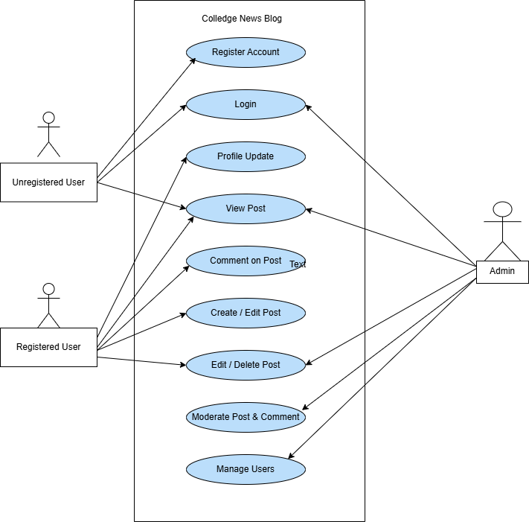

## 3.2. CLASS DIAGRAM

Represents the **structural relationships** between key entities like **User, Post, Category, Comment, and Admin**, defining their attributes, associations, and behaviors.

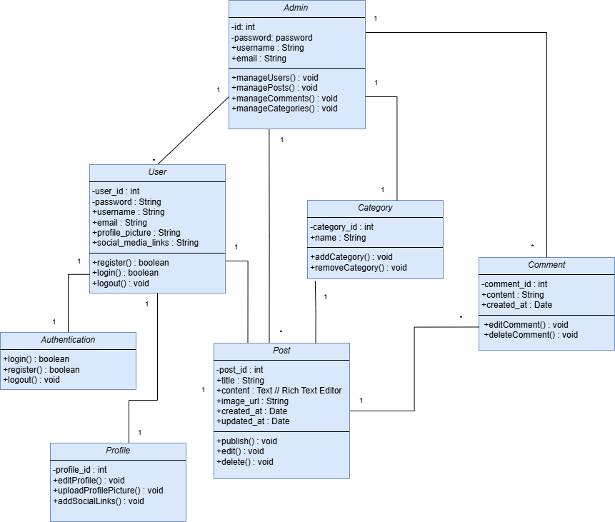

## 3.3. INTERACTION DIAGRAM

Showcases the **step-by-step interactions** between the **User, Website System, and Database** during activities like **logging in, posting, and commenting**.

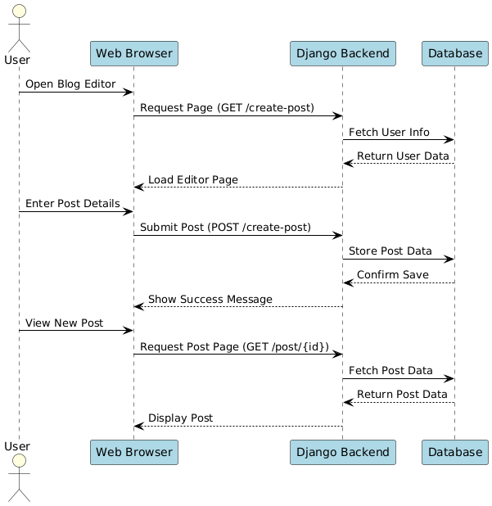

## 3.4. ACTIVITY DIAGRAM

Depicts the **workflow of user interactions** on the blog, including **authentication, post creation, commenting, profile updates, and browsing content**.

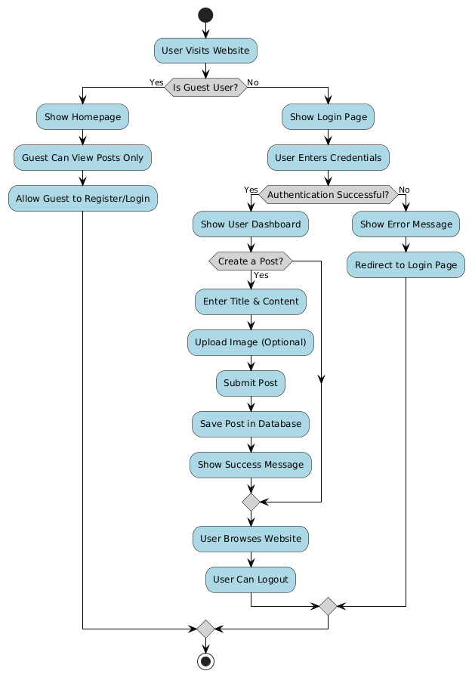

## 3.5. DATA DICTIONARY

|  |  |  |  |  |
| --- | --- | --- | --- | --- |
| **Sr. no** | **Name** | **Datatype** | **Constraint** | **Description** |
| 1 | ID | Integer | Primary Key | To store the User ID |
| 2 | First_name | Varchar (100) | Not Null | To store the first name |
| 3 | Last_name | Varchar(100) | Not Null | To store the last name |
| 4 | Username | Varchar(50) | Unique, Not Null | To store the username |
| 5 | Email | Varchar | Unique, Not Null | To store the email address |
| 6 | Phone | Varchar(10) | Nullable | To store the phone number |
| 7 | Profile_image | Varchar | Nullable | To store the profile image path |
| 8 | Enrollment_number | Varchar(12) | Unique, Not Null | To store the enrollment number |
| 9 | Password | Varchar(128) | Not Null | To store the user password |
| 10 | Confirm_password | Varchar(128) | Not Null | To store the confirmed password |
| 11 | User_permissions | ManyToMany | Nullable | To store user permissions |

CATEGORY

|  |  |  |  |  |
| --- | --- | --- | --- | --- |
| **Sr No.** | **Field Name** | **Data Type** | **Constraints** | **Description** |
| 1 | Category_Name | CharField(100) | Required | Category name |

NEWS

|  |  |  |  |  |
| --- | --- | --- | --- | --- |
| **Sr No.** | **Field Name** | **Data Type** | **Constraints** | **Description** |
| 1 | Title | CharField(255) | Required | News article title |
| 2 | Sub_title | CharField(255) | Required | News article subtitle |
| 3 | Category | ForeignKey(Category) | Required | Category of the news |
| 4 | Author | CharField(50) | Required | Author of the news |
| 5 | Content | RichTextField | Optional | Main content of the news |
| 6 | Status | CharField(255) | Required | Status of the news (PUBLISH/DRAFT) |
| 7 | News_image | ImageField | Required | Image associated with the news |
| 8 | Likes | ManyToManyField(User) | Optional | Users who liked the news |
| 9 | Created | DateTimeField | Auto Now Add | Timestamp when news was created |
| 10 | Updated | DateTimeField | Auto Now | Timestamp when news was last updated |

PROFILE

|  |  |  |  |  |
| --- | --- | --- | --- | --- |
| **Sr No.** | **Field Name** | **Data Type** | **Constraints** | **Description** |
| 1 | User | OneToOneField(User) | Required | User associated with the profile |
| 2 | Phone | CharField(15) | Optional | User's phone number |
| 3 | Gender | CharField(1) | Required | User's gender (M/F/O) |
| 4 | Enrollment_number | CharField(12) | Unique, Required | User's enrollment number |
| 5 | Profile_image | ImageField | Optional | User's profile picture |
| 6 | Bio | TextField | Optional | User's bio |
| 7 | Location | CharField(30) | Optional | User's location |
| 8 | Created | DateTimeField | Auto Now Add | Timestamp when profile was created |
| 9 | Updated | DateTimeField | Auto Now | Timestamp when profile was last updated |

COMMENTS

|  |  |  |  |  |
| --- | --- | --- | --- | --- |
| **Sr No.** | **Field Name** | **Data Type** | **Constraints** | **Description** |
| 1 | News | ForeignKey(News) | Required | News article associated with the comment |
| 2 | User | ForeignKey(User) | Required | User who posted the comment |
| 3 | Comment | TextField | Required | Comment text |
| 4 | Created | DateTimeField | Auto Now Add | Timestamp when comment was created |
| 5 | Updated | DateTimeField | Auto Now | Timestamp when comment was updated |

CONTACT

|  |  |  |  |  |
| --- | --- | --- | --- | --- |
| **Sr No.** | **Field Name** | **Data Type** | **Constraints** | **Description** |
| 1 | Name | CharField(100) | Required | Name of the person contacting |
| 2 | Email | EmailField | Required | Contact email |
| 3 | Subject | CharField(200) | Required | Subject of the message |
| 4 | Message | TextField | Required | Message content |
| 5 | Created_at | DateTimeField | Auto Now Add | Timestamp when message was created |

LOGIN :

|  |  |  |  |  |
| --- | --- | --- | --- | --- |
| **Sr No.** | **Field Name** | **Data Type** | **Constraints** | **Description** |
| 1 | Email | EmailField | Unique, Required | User's email address |
| 2 | Password | CharField(128) | Required | User's password |

# **4.** DEVELOPMENT

## 4.1 CODING STANDARDS

### Coding Style

* The following should be kept in mind to maintain a coding style. Such are, Layout, Format, Indentation, organizing code meaningfully, code must be readable and consistent which makes it easy to understand and maintain further.

### Formatting

* Always use comments for description.
* Always use curly braces {and} in conditional statements.

Example:

if (condition)

{

// comment

}

* Order declarations within type groups based upon access modifier and their accessibility.
* Public
* Protected
* Internal
* Private

### Commenting

* All comments should be written in U.S. English.

Use # or “””…””” but do NOT use /* */.

## 4.2 SCREEN SHOTS

HOME PAGE : The homepage provides an overview of the latest college news, featured articles, and trending discussions, ensuring students stay informed about important updates.

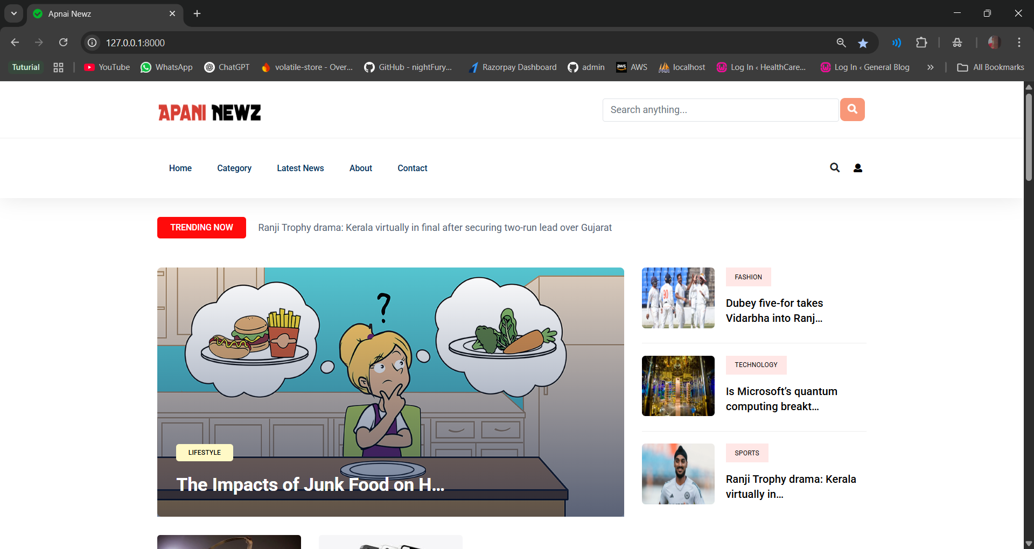

CATEGORIES : Users can explore news and updates organized into various categories such as Academics, Events, Campus Life, Sports, Announcements, Clubs & Societies, and Career Opportunities, making it easier to find relevant information

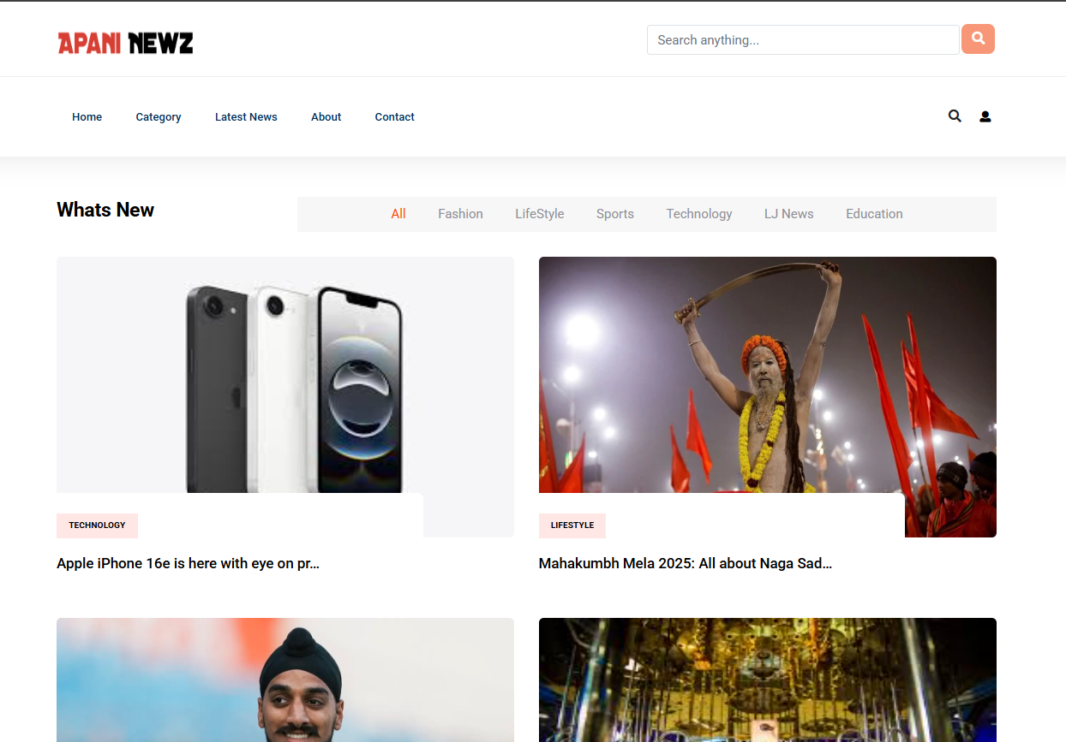

NEWS : Stay updated with the latest college-related announcements, academic updates, event highlights, and student activities, all in one place.

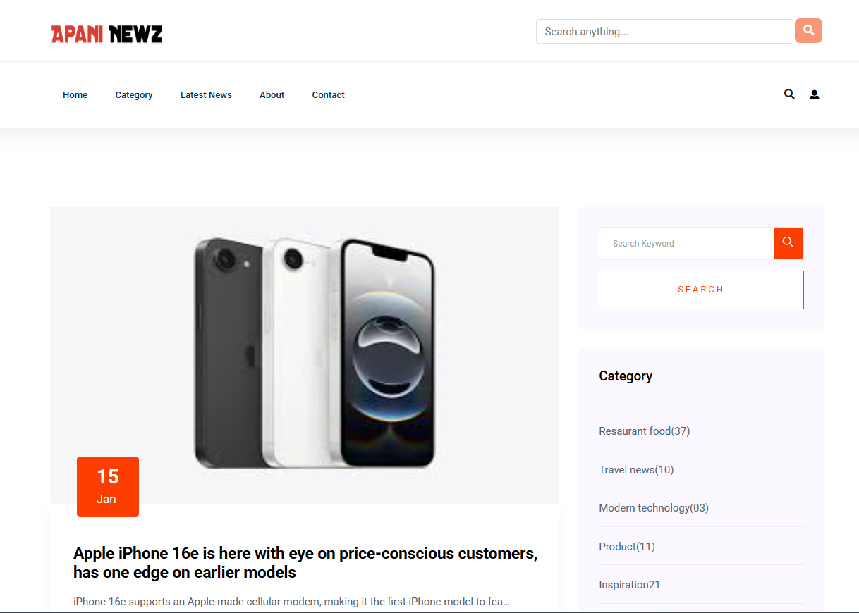

CONTACT FORM : Engage in discussions by sharing your thoughts, asking questions, and interacting with other students through the commenting system on news posts.

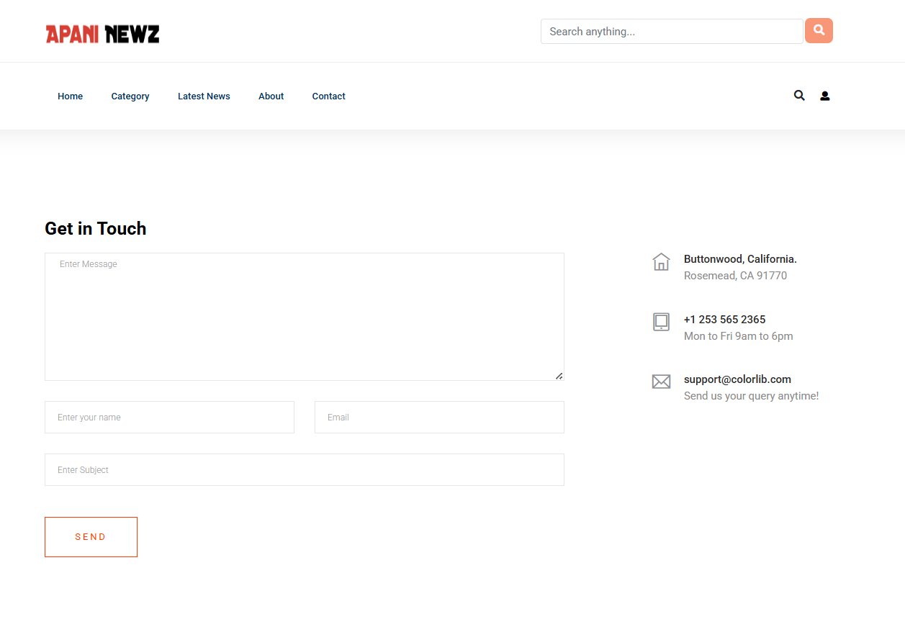

UPDATE PROFILE : Customize your profile by adding a profile picture, updating personal details, and linking social media accounts for better engagement within the college community.

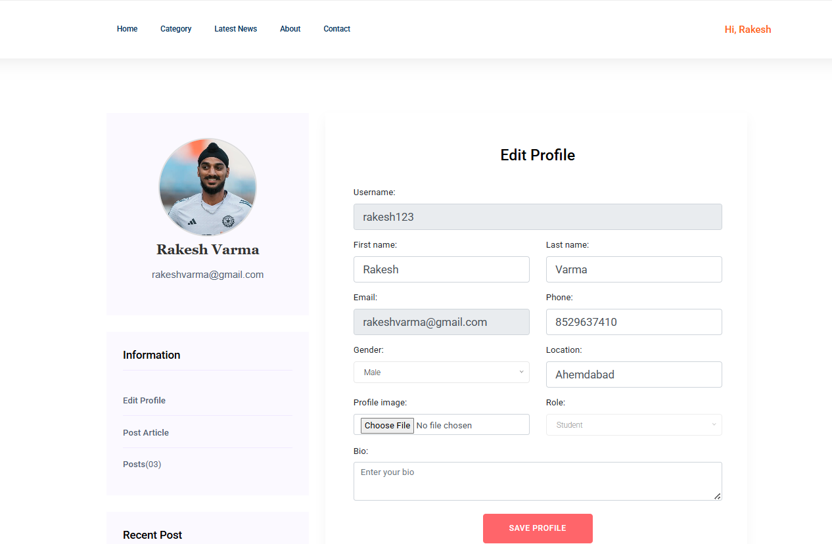

UPLOADING NEWS : Customize your profile by adding a profile picture, updating personal details, and linking social media accounts for better engagement within the college community.

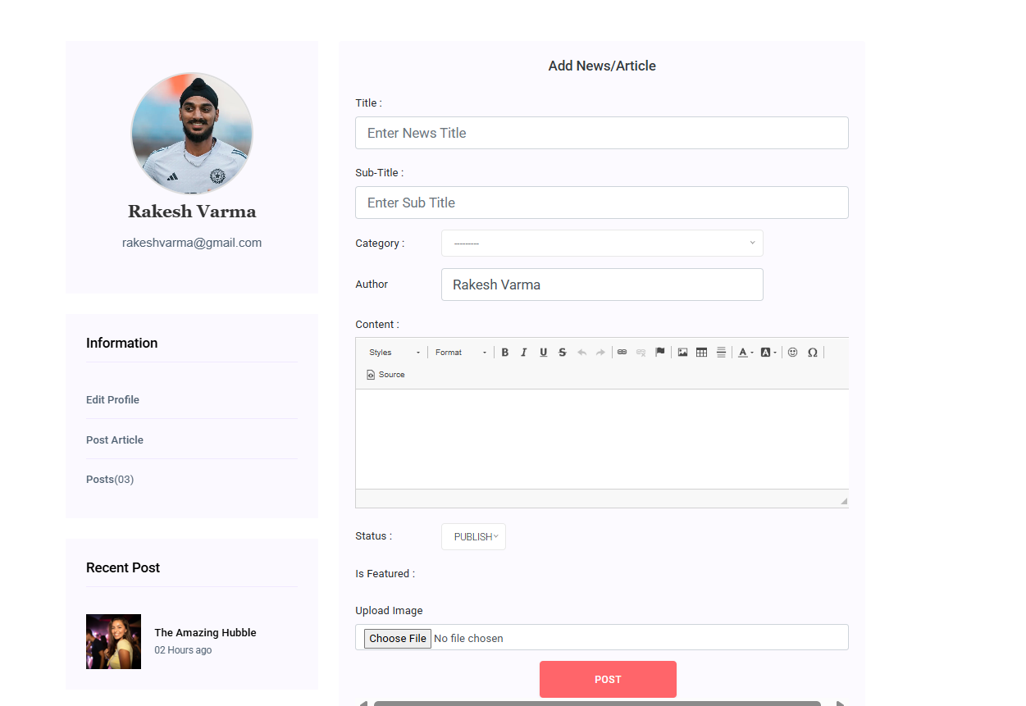

LIKE : Express your support and appreciation for news posts by liking them, helping highlight popular and relevant updates within the college community.

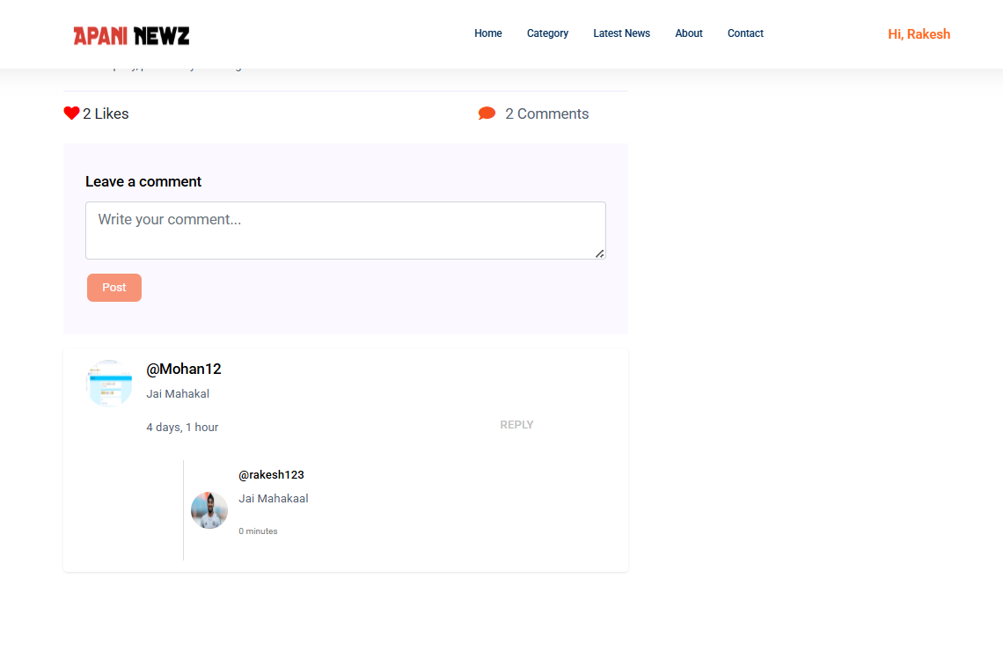

COMMENT : Share your opinions, ask questions, and engage in discussions by commenting on news posts, fostering an interactive and connected college community.

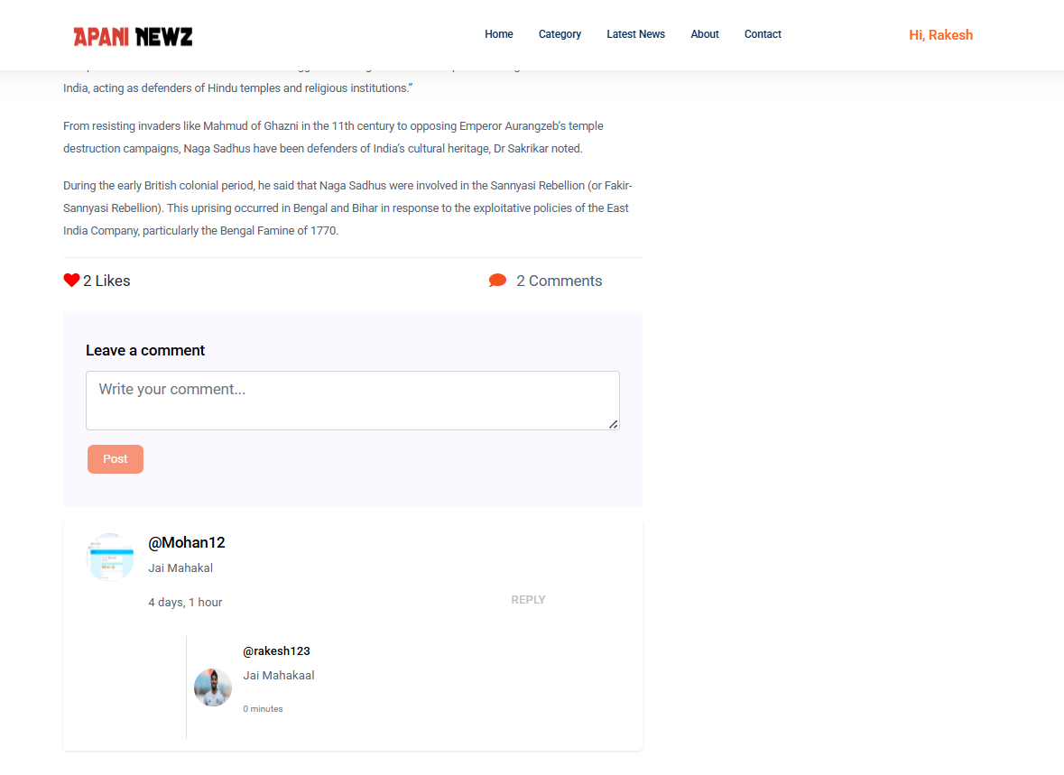

REPLYING TO COMMENT : Engage in meaningful discussions by responding to comments, allowing for interactive conversations and better community engagement.

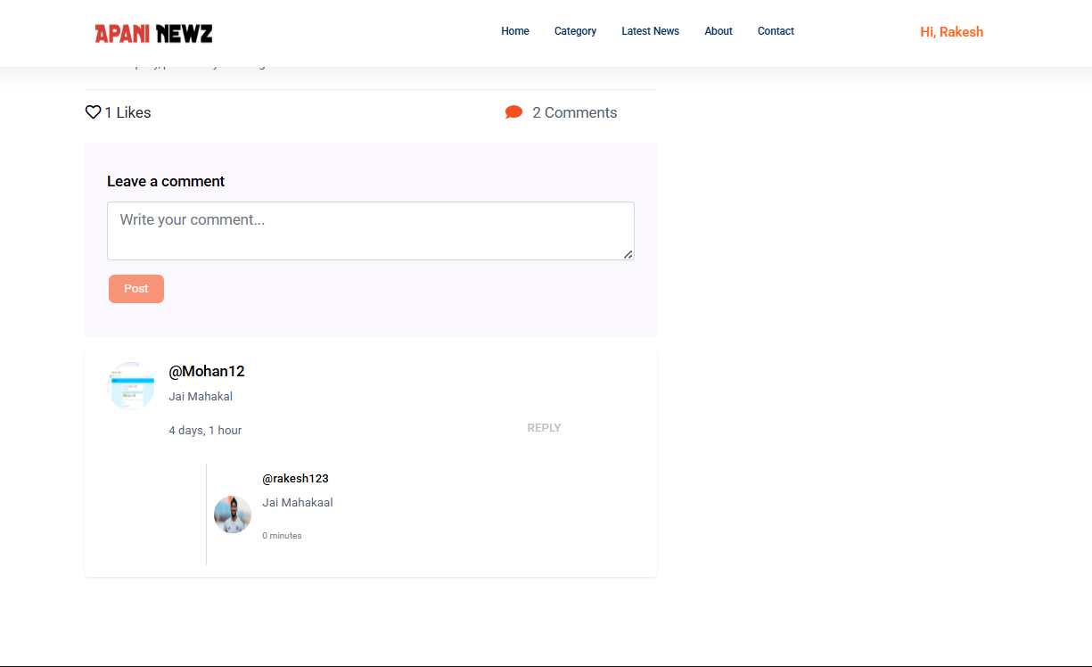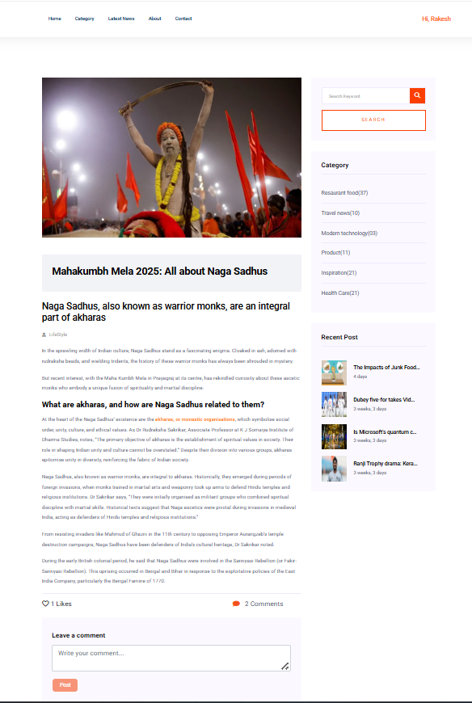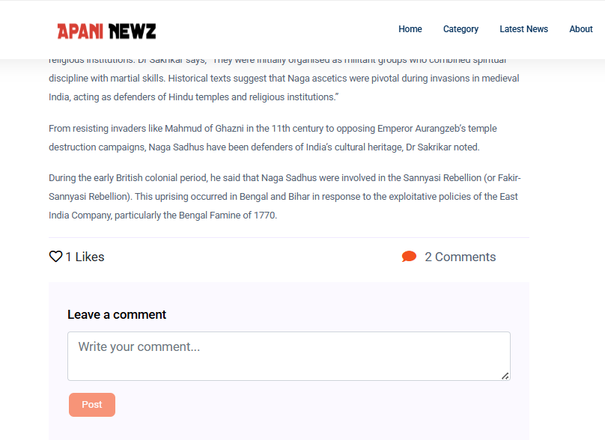

DashboardHome :

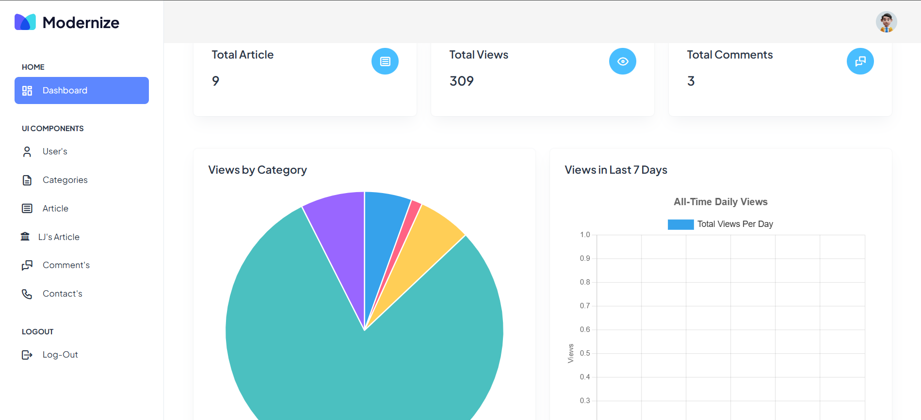

User :

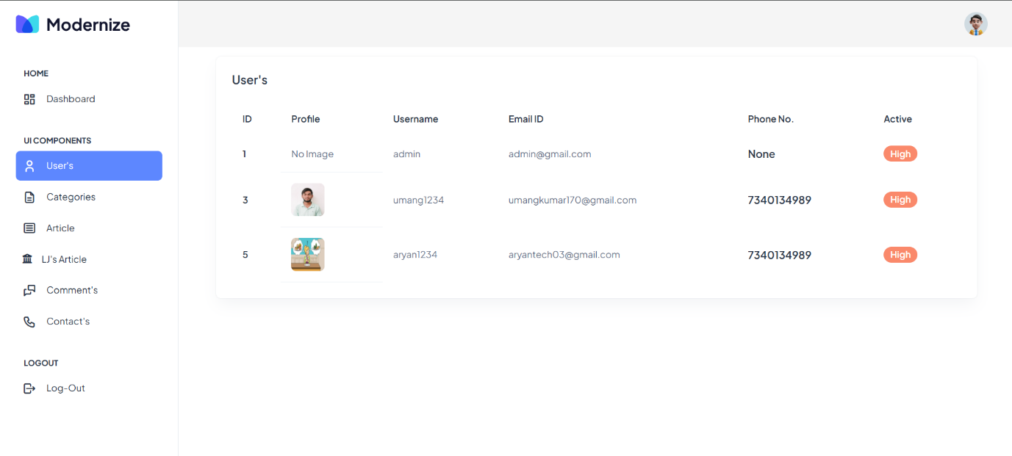

Category :

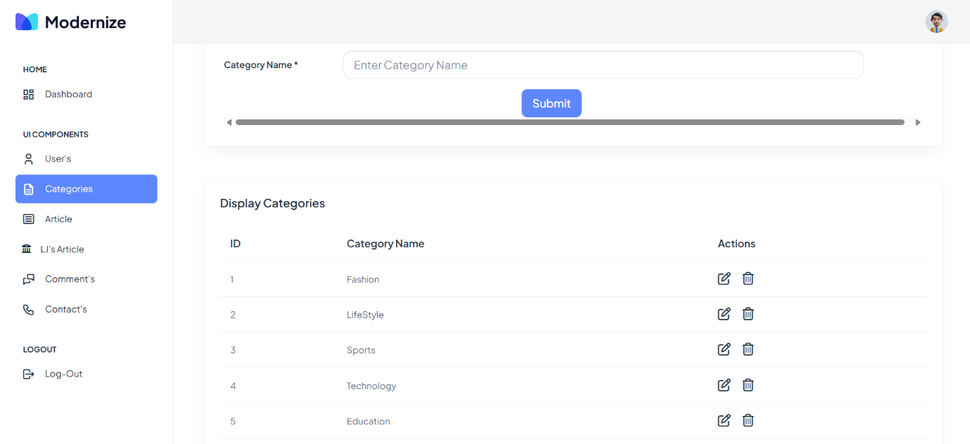

Edit Category :

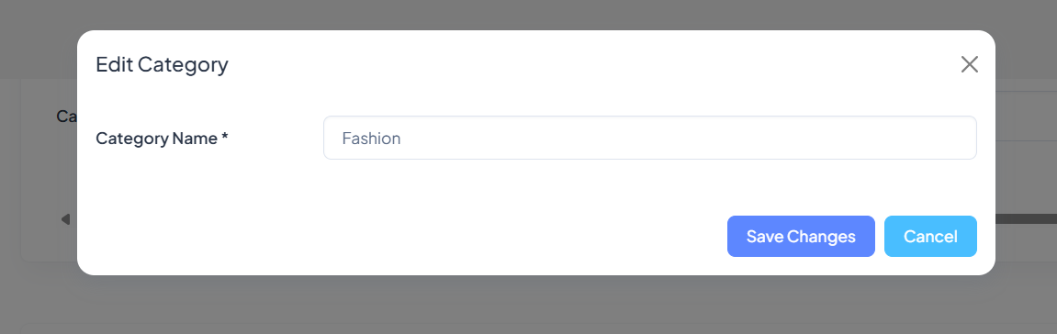

Delete Category :

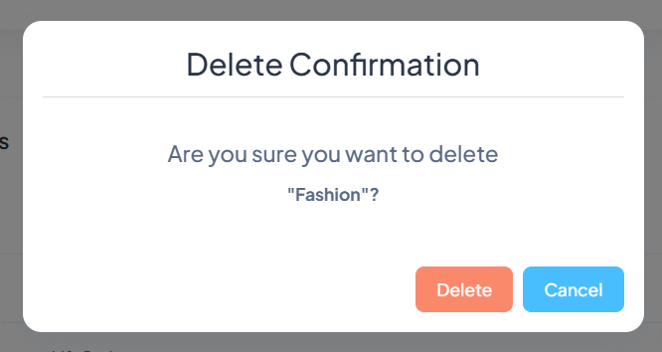

Comments :

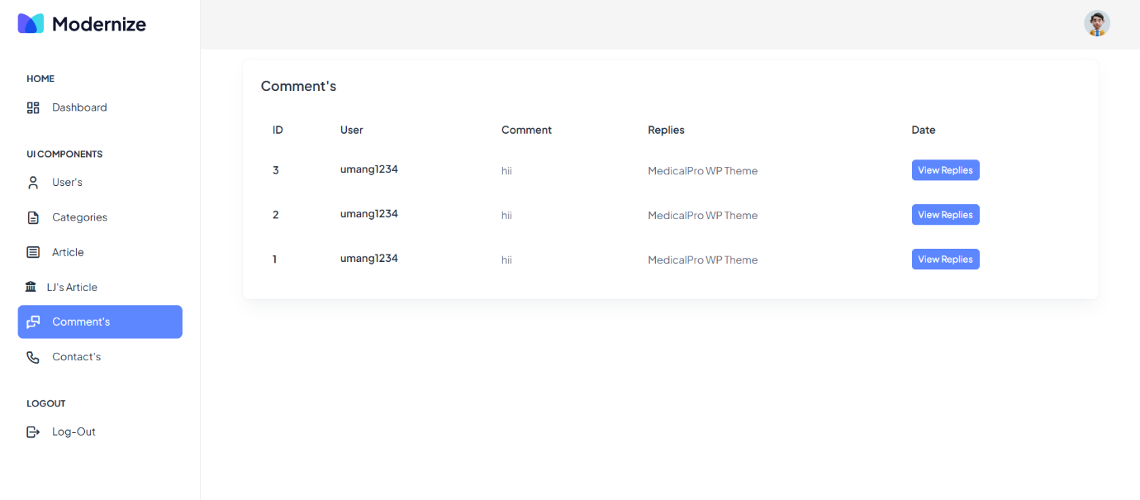

Contact :

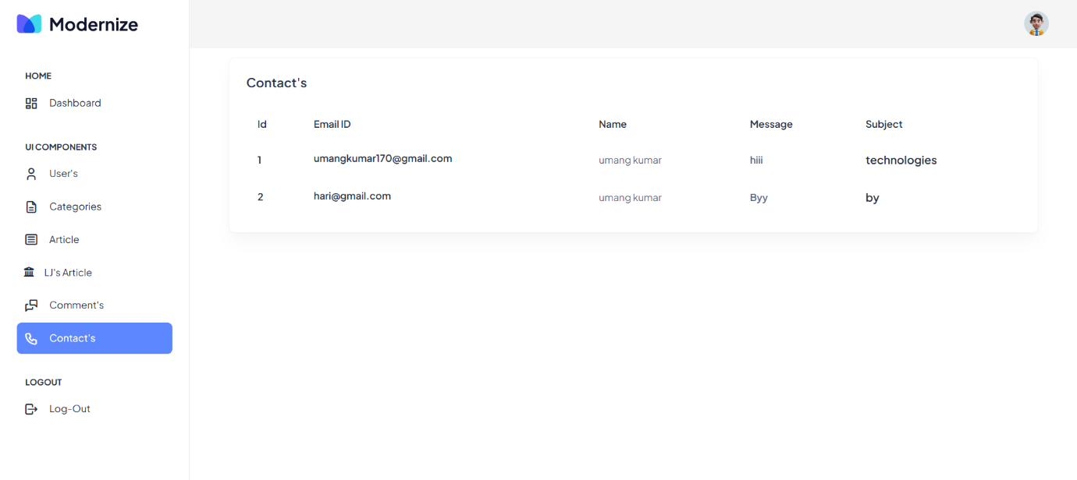

L J News :

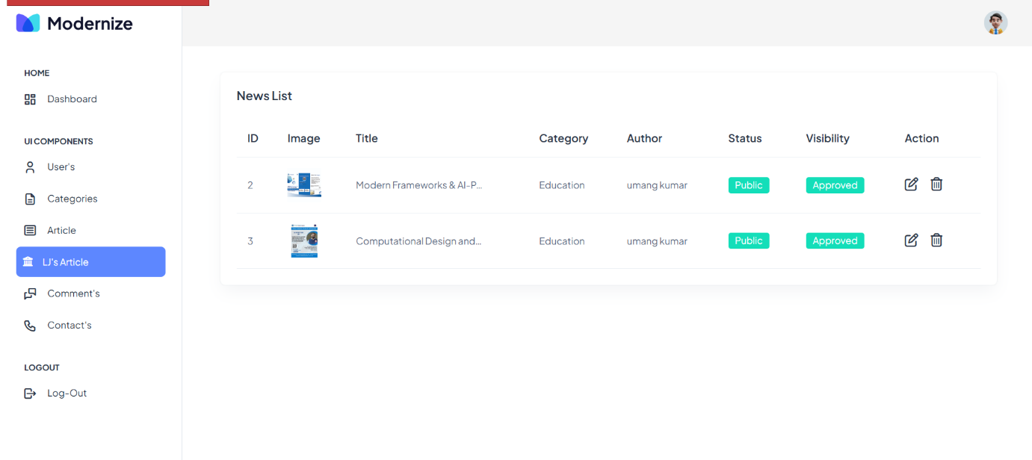

Other Article :

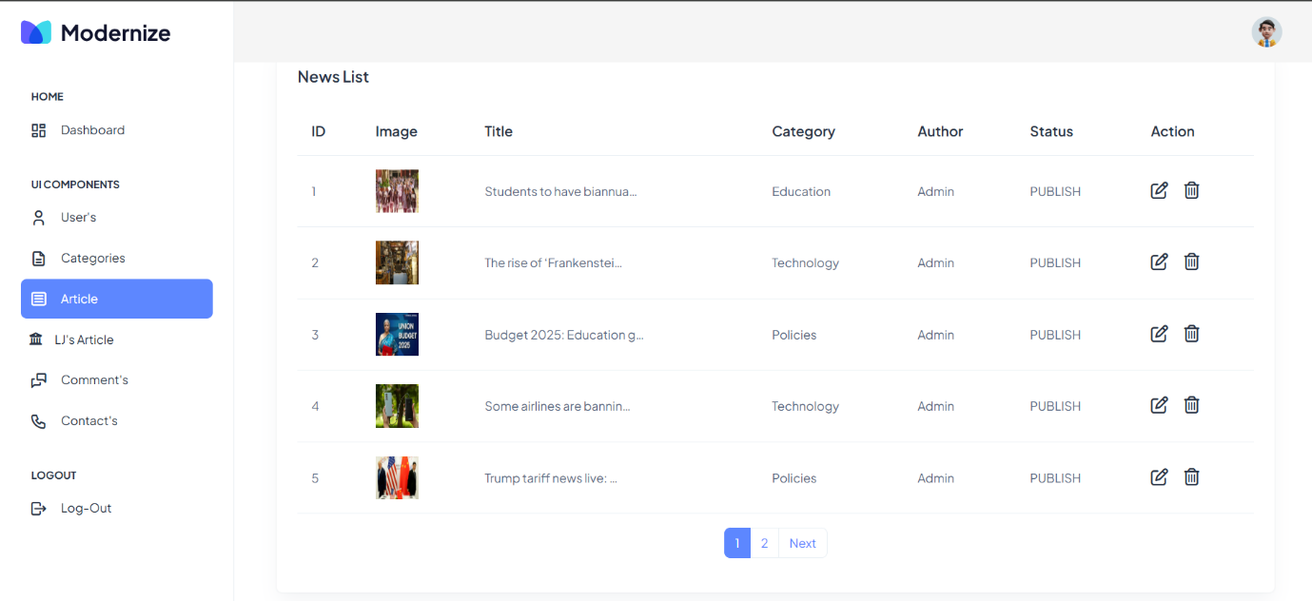

Edit Article :

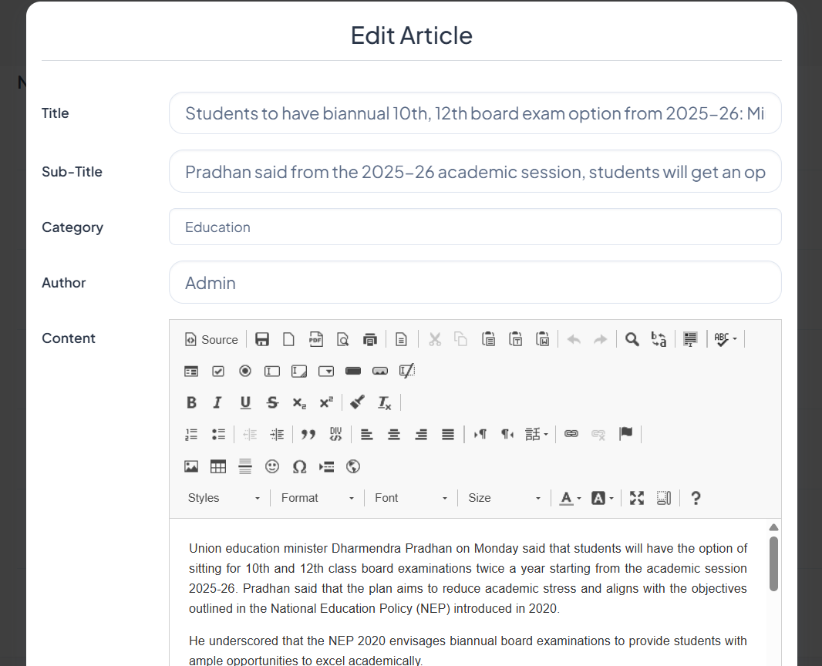

# **5.** AGILE DOCUMENTATION

## 

## 5.1 AGILE PROJECT CHARTER

|  |  |
| --- | --- |
| General Project Information | |
| Project Name | ApniNewz |
| Project Champion | Shah Kalp, Umang Patel, Aryan panchal |
| Project Sponsor | LJ Institute of Computer Application |
| Project Manager | Prof. |
| Stakeholders | Admin , Customer |
| Expected Start Date | 10/01/2025 |
| Expected Completion Date | 15/04/2025 |

|  |  |
| --- | --- |
| Project Details | |
| Mission | To provide a centralized platform where college students can access, share, and engage with relevant academic and extracurricular news. |
| Vision | A seamless digital hub that fosters communication and knowledge-sharing within the college community. The College News Blog enables students to stay informed about academic updates, events, and announcements, promoting a connected and engaged campus environment. |
| Scope | Users can create accounts, publish categorized blog posts, comment, like/unlike posts, and manage personal profiles. The platform ensures secure authentication, a rich text editor for enhanced content formatting, and a mobile-responsive design for accessibility across devices. |
| Date | 15/04/2025 |

## 5.2 AGILE PROJECT ROADMAP

|  |  |  |  |  |  |  |
| --- | --- | --- | --- | --- | --- | --- |
| **Sprint** | **Task Name** | **Jan-15** | **Jan-31** | **Feb-1** | **March-27** | **April-11** |
| 1 | Project Setup & Database Design |  | |  |  |  |
| 2 | User_Authentication (Register/Login/Logout) |  |  | |  |  |
| 3 | Password Reset & Profile Management |  |  | |  |  |
| 4 | Blog Post Management (Create, Edit, Delete) |  |  |  |  |  |
| 5 | Categorization & Filtering of Posts |  |  |  |  |  |
| 6 | Commenting System & Like/Unlike Feature |  |  |  |  |  |
| 7 | Rich Text Editor & Image Uploads |  |  |  |  |  |
| 8 | Mobile Responsiveness & UI Enhancements |  |  |  |  |  |
| 9 | Testing & Bug Fixing |  |  |  |  |  |
| 10 | Deployment |  |  |  |  |  |
| 11 | Documentation |  |  |  |  |  |

## 5.3 AGILE PROJECT PLAN

|  |  |  |  |  |
| --- | --- | --- | --- | --- |
| **Task Name** | **Duration** | **Start** | **Finish** | **Status** |
| **Sprint#1: Project Structure** | 5d | 10/01/2025 | 14/01/2025 | Completed |
| **UI Designing** | 6d | 15/01/2025 | 21/01/2025 | Completed |
| **Database Management** | 4d | 22/01/2025 | 25/01/2025 | Completed |
| **Sprint#2: User Authentication** | 4d | 26/01/2025 | 29/01/2025 | Completed |
| **Customer Registration** | 4d | 30/01/2025 | 04/02/2025 | Completed |
| **Sprint#3: Login and Logout** | 3d | 05/02/2025 | 07/02/2025 | Completed |
| **Customer Login** | 2d | 08/02/2025 | 09/02/2025 | Completed |
| **Admin Login** | 2d | 10/02/2025 | 11/02/2025 | Completed |
| **Sprint#4: Password Reset & Profile Management** | 2d | 12/02/2025 | 13/02/2025 | Completed |
| **Password Reset Functionality** | 2d | 14/02/2025 | 17/02/2025 | Completed |
| **Sprint#5: Blog Post Management** | 7d | 18/02/2025 | 24/02/2025 | Completed |
| **Create, Edit, Delete Blog Posts** | 7d | 25/02/2025 | 03/03/2025 | Completed |
| **Sprint#6: Categorization & Filters** | 7d | 04/03/2025 | 10/03/2025 | Completed |
| **Categorize Posts by Topic** | 2d | 11/03/2025 | 12/03/2025 | Completed |
| **Filtering System** | 3d | 13/03/2025 | 17/03/2025 | Completed |
| **Sprint#7: Cart** | 3d | 18/03/2025 | 20/03/2025 | Completed |
| **Commenting System** | 1d | 21/03/2025 | 21/03/2025 | Completed |
| **Like/Unlike Functionality** | 3d | 22/03/2025 | 24/03/2025 | Completed |
| **Sprint#8: Rich Text Editor & Image Upload** | 3d | 25/03/2025 | 27/03/2025 | Completed |
| **Sprint#9: Mobile Responsiveness & UI Enhancements** | 2d | 28/03/2025 | 31/03/2025 | Completed |
| **Sprint#10: Testing & Deployment** | 4d | 01/04/2025 | 04/04/2025 | Completed |
| **Final Adjustments & Buffer** | 7d | 07/04/2025 | 15/04/2025 | Completed |

## 5.4 AGILE USER STORY

|  |  |  |  |
| --- | --- | --- | --- |
| **User Story ID** | **As a (type of user)** | **I want to (perform some task)** | **So that I can (achieve some goal)** |
| **1** | Admin | Manage Login Module | Ensure that only valid users can access the platform |
| **2** | Admin | Manage Blog Posts | Create, edit, delete, and organize news content |
| **3** | Admin | Manage Comments | Ensure discussions remain appropriate and relevant |
| **4** | Admin | Manage Categories | Organize posts into relevant topics for easy navigation |
| **5** | Visitor | View Blog Posts | Access college-related news and updates |
| **6** | Visitor | Search Posts | Find specific articles quickly based on keywords or categories |
| **7** | Registered User | Create Blog Posts | Share important news and events with the college community |
| **8** | Registered User | Edit and Delete My Posts | Manage my published content |
| **9** | Registered User | Comment on Blog Posts | Engage in discussions and share my opinions |
| **10** | Registered User | Like/Unlike Posts | Show appreciation or feedback on posts |
| **11** | Registered User | Manage My Profile | Update my profile information and upload a profile picture |
| **12** | Registered User | Receive Notifications | Stay updated on new posts, comments, or likes |
| **13** | Mobile User | Access the Blog on Mobile | Browse the site seamlessly on different devices |

## 5.5 AGILE RELEASE PLAN

|  |  |  |  |
| --- | --- | --- | --- |
| **Task Name** | **Duration** | **Start** | **Finish** |
| **Sprint#1: Project Structure** | 7d | 10/01/2025 | 16/01/2025 |
| **UI Designing** | 4d | 17/01/2025 | 20/01/2025 |
| **Database Management** | 3d | 21/01/2025 | 23/01/2025 |
| **Sprint#2: Registration** | 5d | 24/01/2025 | 28/01/2025 |
| **Registration, Login, Logout** | 5d | 29/01/2025 | 02/02/2025 |
| **Sprint#3: Password Reset** | 4d | 03/02/2025 | 06/02/2025 |
| **Sprint#4: Blog Post Management** | 2d | 07/02/2025 | 08/02/2025 |
| **Create, Edit, Delete** | 2d | 10/02/2025 | 11/02/2025 |
| **Sprint#5: Categorization** | 9d | 12/02/2025 | 20/02/2025 |
| **Filtering of Posts** | 9d | 21/02/2025 | 03/03/2025 |
| **Sprint#6: Commenting System** | 5d | 04/03/2025 | 08/03/2025 |
| **Sprint#7: Rich Text Editor** | 6d | 10/03/2025 | 15/03/2025 |
| **Image Uploads** | 4d | 17/03/2025 | 20/03/2025 |
| **Sprint#8: Contact Form** | 1d | 21/03/2025 | 21/03/2025 |
| **User Contact Admin** | 1d | 22/03/2025 | 22/03/2025 |
| **Sprint#9: Notifications** | 14d | 24/03/2025 | 06/04/2025 |
| **Customer Place Order** | 4d | 07/04/2025 | 10/04/2025 |
| **Sprint#10: Mobile Responsiveness** | 1d | 11/04/2025 | 11/04/2025 |
| **Final Wrap-Up** | 2d | 14/04/2025 | 15/04/2025 |

## 5.6 AGILE SPRINT BACKLOG

|  |  |  |  |  |  |
| --- | --- | --- | --- | --- | --- |
| **Task Name** | **Story** | **Sprint Ready** | **Priority** | **Status** | **Story Point** |
| **Sprint#1: Project Structure** | Yes | Yes | High | Completed | 3 |
| UL Designing | Yes | Yes | High | Completed | 2 |
| Database Management | Yes | Yes | High | Completed | 2 |
| **Sprint#2:** User Authentication | Yes | Yes | High | Completed | 2 |
| Registration | Yes | Yes | High | Completed | 1 |
| Login & Logout |  |  |  |  |  |
| **Sprint#3:** Profile Management | Yes | Yes | High | Completed | 4 |
| **Sprint#4:** Blog Post Management | Yes | Yes | High | Completed | 3 |
| **Sprint#5:** Categorization | Yes | Yes | High | Completed | 4 |
| Create, Edit, Delete | Yes | Yes | High | Completed | 4 |
| **Sprint#6:** Commenting System | Yes | Yes | High | Completed | 4 |
| **Sprint#7:** Rich Text Editor | Yes | Yes | Medium | Completed | 4 |
| **Sprint#8:** Contact Form | Yes | Yes | Low | Completed | 1 |
| User Contact to Admin | Yes | Yes | Low | Completed | 1 |
| **Sprint#9:** Post Filtering | Yes | Yes | High | Completed | 4 |
| By Category | Yes | Yes | High | Completed | 4 |
| By Tag |  |  |  |  |  |
| By Author |  |  |  |  |  |
| **Sprint#10:** Notifications | Yes | Yes | Medium | Completed | 2 |
| **Sprint#11:** Mobile Responsiveness | Yes | Yes | High | Completed | 5 |

## 5.7 AGILE TEST PLAN

|  |  |
| --- | --- |
| Test Case ID: 101 | Test Case Name: Customer Login |
| Designed by: Shah Kalp | Design Date: 10/08/2025 |
| Module Name: User Login | Sub Module Name: Login |
| Executed by: Shah Kalp | Execution Date: 10/03/2025 |
| Brief Description: User Login  With Data: “email: shahtatva118@gmail.com& password:tatva123” | Test Priority (Low/Medium/High): High |
| Pre-Conditions: User Must Registered  & have | Correct Username & Password. |
| Dependencies: None |  |

|  |  |  |  |  |  |
| --- | --- | --- | --- | --- | --- |
| Test Step | Test Data | Expected Result | Actual Result | Status (Pass/Fail) | Remarks |
| 1 | Email: t@g.com  Password: 1234 | Successfully login & redirect to  Home Page. | Login Successful. | Pass | None |
| 2 | Email: t1@g.com  Password: 1234 | Show “Invalid Credentials.” | Login Not Successful | Fail | Need to Show Error  Message. |
| 3 | Email: t2@g.com  Password: 1234Mah | Show “Invalid Credentials.” | Login Not Successful | Fail | Need to Show Error  Message. |
| 4 | Email: t2@g.com  Password: 1234 | Successfully login in to system &  redirect to home Page. | Login Successful & Redirect to home Page. | Pass | None |

|  |  |
| --- | --- |
| Test Case ID: 102 | Test Case Name: User Registration |
| Designed by: Umang patel | Design Date: 10/08/2025 |
| Module Name: User Registration | Sub Module Name: Register |
| Executed by: Umang patel | Execution Date: 10/03/2025 |
| Brief Description: User Registration page for the new user. User needs to provide  the correct details for Registration. | Test Priority (Low/Medium/High): High |
| Pre-conditions: None | |
| Dependencies: Username & Password are store. | |

|  |  |  |  |  |  |
| --- | --- | --- | --- | --- | --- |
| Test Step | Test Data | Expected Result | Actual Result | Status (Pass/Fail) | Remarks |
| 1 | First Name: umang Last Name: patel Email: [u@gmail.com](mailto:u@gmail.com) Password: 1234 Confirm Password:  1234 | Successfully Registered & Redirect to Login Page. | Registered Successfully. | Pass | redirect to login Page. |
| 2 | First Name: umang Last Name: patel Email: [u1@gmail.com](mailto:u1@gmail.com) Password: 1234 Confirm Password:  12345 | Show Error Message as “Password & Confirm  Password must be Equal” | Not Registered & remain in Registration page. | Fail | None |
| 3 | First Name: Piyush Last Name: Jain Email: [u2@gmail.com](mailto:u2@gmail.com) Password: 1234 Confirm Password:  1234 | Show Error Message as “Email  I’d Already Exist” | Not Registered & remain in Registration page. | Fail | None |
| 4 | First Name: Tushar Last Name: Sid Email: [u3@gmail.com](mailto:u3@gmail.com) Password: 4321 Confirm Password:  4321 | Successfully Registered & | Successfully Registered & | Pass | None |

|  |  |
| --- | --- |
| Test Case ID: 103 | Test Case Name: User Authentication (Login & Logout) |
| Designed by: Shah Kalp | Design Date: 10/08/2025 |
| Module Name: User Authentication | Sub Module Name: Add Product |
| Executed by: Shah Kalp | Execution Date: 10/03/2025 |
| Brief Description: Users should be able to log in and log out securely. | Test Priority (Low/Medium/High): High |
| Pre-conditions: User must have a registered account. | |
| Dependencies: Database must store valid user credentials. | |

|  |  |  |  |  |  |
| --- | --- | --- | --- | --- | --- |
| Test | Test Step | Action | Expected Result | Actual Result | Status (Pass/Fail) |
| 1 | Navigate to Login Page | User accesses the login page | Login page should load correctly | Login page loads successfully | Pass |
| 2 | Enter valid credentials | User enters correct email & password | User should be redirected to the dashboard | User is redirected successfully | Pass |
| 3 | Enter incorrect credentials | User enters invalid email or password | Error message should appear | Error message appears correctly | Pass |
| 4 | Click on "Logout" Button | User logs out from the session | User should be redirected to the homepage | User is logged out successfully | Pass |
| 5 | Try accessing a restricted page after logout | User attempts to visit the dashboard without logging in | User should be redirected to the login page | User is correctly redirected | Pass |

|  |  |
| --- | --- |
| Test Case ID: 104 | Test Case Name: Commenting System |
| Designed by: Umang Patel | Design Date: 10/08/2025 |
| Module Name: Blog Post Module | Sub Module Name: Add Comment |
| Executed by: Umang Patel | Execution Date: 10/03/2025 |
| Brief Description: Users can comment on blog posts and engage in discussions. | Test Priority (Low/Medium/High): High |
| Pre-conditions: User must be Logged in. | |
| Dependencies: Blog Post must exist | |

|  |  |  |  |  |  |
| --- | --- | --- | --- | --- | --- |
| Test | Test Step | Action | Expected Result | Actual Result | Status (Pass/Fail) |
| 1 | Click on the comment section under a post | User types a comment and clicks "Post" | Comment should be added under the post | Comment is not displayed | Fail |
| 2 | Click on "Edit" for an existing comment | User edits the comment and saves changes | Comment text should be updated | Comment text updates successfully | Pass |
| 3 | Click on "Delete" for an existing comment | User deletes the comment | Comment should be removed | Comment is removed | Pass |
| 4 | Post an empty comment | User tries to submit without typing | Error message should appear | Error message appears correctly | Pass |
| 5 | Like a comment | User clicks the "Like" button on a comment | Like count should increase | Like count increases successfully | Pass |

|  |  |
| --- | --- |
| Test Case ID: 105 | Test Case Name: Payment |
| Designed by: Shah Kalp | Design Date: 10/08/2025 |
| Module Name: Payment | Sub Module Name: Payment |
| Executed by: Shah Kalp | Execution Date: 10/03/2025 |
| Brief Description: payment for products | Test Priority (Low/Medium/High): High |
| Pre-conditions: User must be Logged in. | |
| Dependencies: None | |

|  |  |  |  |  |  |
| --- | --- | --- | --- | --- | --- |
| Test | Test Step | Action | Expected Result | Actual Result | Status (Pass/Fail) |
| 1 | Click on Checkout Button | Show the All-Payment options | All the Payment options are visible | All the Payment options are visible | Pass |
| 2 | Click on Cash on Delivery Option | Selected option  Process is Start | Start the process and Product Order  is Done Successfully | Start the process and Product  Order is Done Successful | Pass |
| 3 | Click On Cart Online Payment | Need To Filled up All mandatory information | Start online Payment Process | Start online Payment Process | Pass |
| 4 | Successful for add the mandatory information | Ask for right strip number, cvv, date | Online payment Process is Done Successfully | Online payment Process is Done Successfully | Pass |
| 5 | Successful for add the mandatory information | Ask strip number, cvv, date | If Add Credit card or Dedit card Number | Online payment Process is Not start | Fail |
| 6 | Successful for add the mandatory information | Ask for wrong strip number, cvv, date | Online payment Process is Not start | Online payment Process is Not start | Fail |

## 5.8 EARNED-VALUE AND BURN CHARTS

|  |  |  |
| --- | --- | --- |
| Task | Plan Days | Actual Days |
| 0 |  |  |
| 1 | 5 | 7 |
| 2 | 3 | 5 |
| 3 | 3 | 4 |
| 4 | 2 | 2 |
| 5 | 6 | 9 |
| 6 | 4 | 5 |
| 7 | 5 | 6 |
| 8 | 1 | 1 |
| 9 | 10 | 15 |
| 10 | 5 | 8 |
| 11 | 5 | 10 |

**Burn Chart**

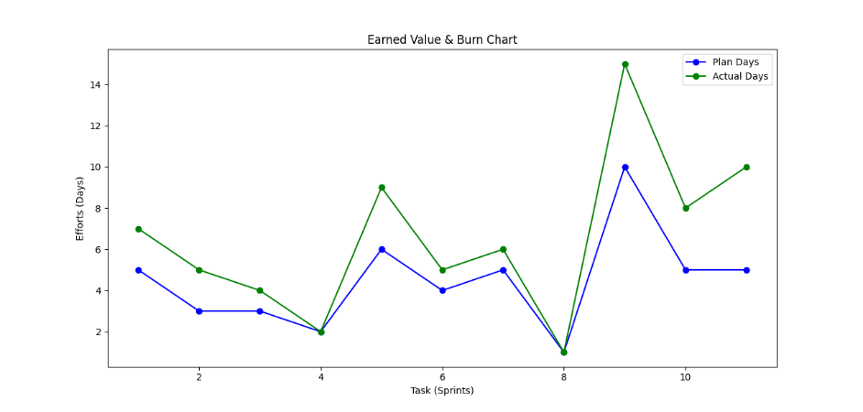

# **6. PROPOSED ENHANCEMENTS**

While the current version of the College News Blog platform offers a solid foundation, several enhancements can be made to improve functionality, user experience, and scalability. Proposed enhancements include:

* **Multilingual Support**: Adding multilingual capabilities to allow users to access the platform in different languages, ensuring inclusivity for a diverse student population.
* **Search Functionality**: Implementing a search feature that allows users to find posts by keywords, categories, or dates, making the platform more navigable.
* **Advanced User Roles and Permissions**: Expanding the user role system to include editors, content managers, and moderators, each with specific access rights to manage content and users.
* **Real-Time Notifications**: Implementing a notification system to alert users about new posts, comments, or replies to their posts, enhancing user engagement.
* **Analytics Dashboard**: Adding an analytics feature for administrators to track user engagement, popular posts, and other metrics to better understand platform usage.
* **Event Calendar Integration**: Integrating a calendar feature that allows users to publish and view important college events, meetings, and deadlines.
* **Video Content Support**: Allowing users to upload and share video content in addition to images, enhancing the type of media that can be shared on the platform.
* **API Integration**: Developing an API for the blog platform to allow external applications or services to interact with the system, such as fetching posts or submitting new content.

# **7. CONCLUSIONS**

The College News Blog project successfully meets the need for a centralized platform where college students, faculty, and staff can share and access important news and updates. By implementing a user-friendly interface, secure authentication, and interactive features like comments and "like" functionality, the platform fosters engagement and collaboration within the college community.

The development process followed a structured Agile methodology, ensuring incremental progress and flexibility to accommodate changes as needed. Through this project, we not only achieved the technical goals but also gained valuable experience in full-stack web development using Django and other modern technologies.

The proposed future enhancements, including multilingual support, search functionality, and advanced user roles, promise to further expand the platform's capabilities, making it a more inclusive and robust tool for the college community.

In conclusion, the College News Blog serves as an important step toward improving communication within the college while offering students and developers alike a meaningful learning experience in building dynamic web applications.

# **8. BIBLIOGRAPHY**

**Books**:

* "Django for Beginners" by William S. Vincent
* "Python Crash Course" by Eric Matthes
* "Clean Code: A Handbook of Agile Software Craftsmanship" by Robert C. Martin

**Online Resources**:

* Codemy.com YouTube Playlist on Django: <https://www.youtube.com/c/Codemycom>
* Django Documentation: <https://docs.djangoproject.com/en/stable/>
* W3Schools for Bootstrap: <https://www.w3schools.com/bootstrap4/>

**Research Papers**:

* "A Study on the Agile Software Development Process" – Journal of Software Engineering, 2021.
* "Web Application Security: A Survey of Best Practices" – International Journal of Computer Science, 2020.

**Tools**:

* GitHub: <https://github.com/>
* Bootstrap: <https://getbootstrap.com/>
* Django Framework: <https://www.djangoproject.com/>